DB Details:

**Access and Credentials:**

This is the connection string of Mongo DB in Dev

mongodb+srv://develop_monitor:demo1234!@desktop-develop-ysuuy.gcp.mongodb.net/q4?retryWrites=true&w=majority

FactSet ownership tables in staging:

postgres://q4admin:canttouchthis6!@ownership-stage.cot05bjvn55c.us-east-1.rds.amazonaws.com:5432/q4_ownership

username: q4admin

password: canttouchthis6!

For APIs we can use Postman or Xignite. Below are the Xignite details:

Xignite : <https://www.xignite.com/Login>

username: xignite@q4websystems.com

password: Xignite123

xignite.comxignite.com

Member Sign-in/Sign-up

Login to Xignite or sign up for an account.

Barchart (commodities): <https://ondemand.websol.barchart.com/getCompetitors.json>

API key : a0e64434b28ef4ae0d82decab1dfc295

**For Data Testing we need to access 3 DBs:**

**Schema**

1. Cyclops(Surveillance) - It has only production environment(DB = StockSurveillanceProd) for now. Staging and Dev is not available for Cyclops. Access it through MS SQL Server Management Studio. It update itself from the FactSet Terminal.

Cyclops Frontend (UI)- Remote desktop : Make a connection to the cyclops using below credentials. Set cyclops gateway: quantrdpgw.q4preview.com, Remove the Inheritance checkbox.

**Login Credentials:**

q4quant\quant-dev

0bc88R!sr1kbZnms

Check the “Use a TS Gateway server” box and enter  [quantrdpgw.q4preview.com](http://quantrdpgw.q4preview.com/)  in the server name in gateway settings

1. Factset(PgAdmin, DB name - q4_ownership) - It has all the 3 environments: Download (<https://www.postgresql.org/ftp/pgadmin/pgadmin4/v4.14/windows/>) pgadmin and set to the following. Postgresql / factset is updates itself from the factset terminal.

Password: q4pass1234!

**Note**: If it breaks create a new instance of it by clicking on the right bottom corner of the task bar by rightclicking on pgadmin icon and shut down then restart from the start menu.

1. MongoDB - It has all the 3 environments. It's terminal is 'FactSet Terminal'. FactSet Terminal is connected using Remote desktop connection manager. Before conneting to DB make sure Remote factset machine is on. Mongo DB is updates itself from the FactSet Terminal.

Below link has all the information including server name, user name and password

mongodb+srv://develop_monitor:demo1234!@desktop-develop-ysuuy.gcp.mongodb.net/q4?retryWrites=true&w=majority

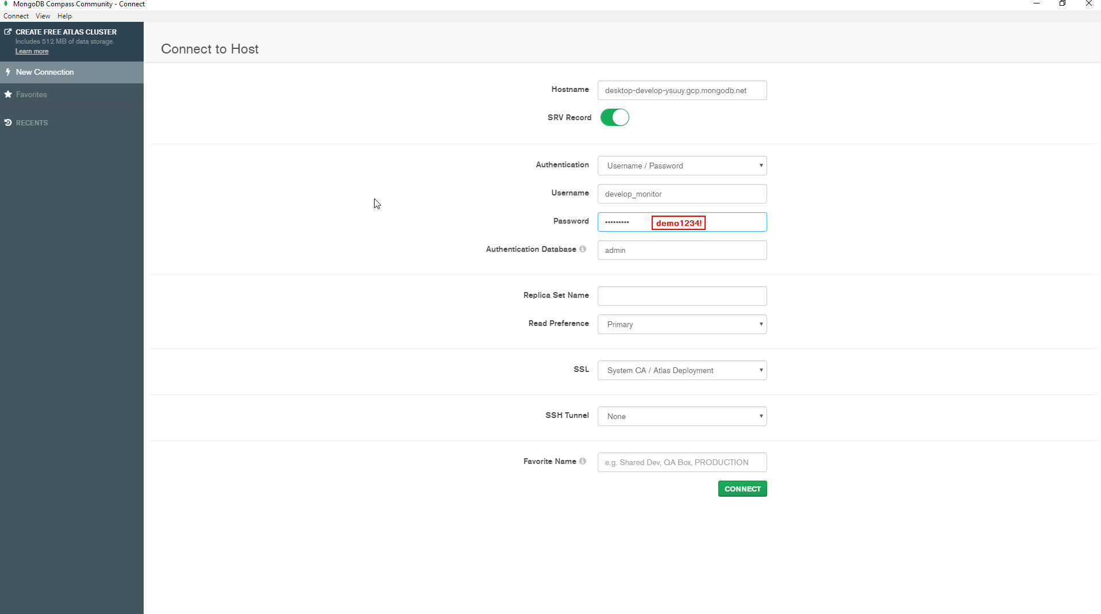

factset-desktop.office.q4inc.com

user: office.q4inc.com\factset user

pass : B0b@Fett

Uncheck the Inherit checkbox

API Testing: (Team: Q4 Desktop, Collection: Serverless-q4stock)

For the APIs, below are the API-Keys ({{BARCHART_API_KEY}})

xignite api : FEEFDD0D00744DB4A1A26D6D6E6C3915

barchart: a0e64434b28ef4ae0d82decab1dfc295

Get Access to the following sites:

<https://staging.q4desktop.com/login> - Ask someone who has the access to it they can create credetials for you.

<https://admin-dev.q4inc.com/#/home> - It is gmail office account and same password.

Test Rail:

Test Cases are located here for Data Testing: <https://q4web.testrail.com/index.php?/dashboard> - Look for Data Discrepancy.

<https://q4web.testrail.com/index.php?/suites/view/4166&group_by=cases:section_id&group_order=asc>

Automation:

Download Python and install it: <https://www.python.org/downloads/>

<https://www.ics.uci.edu/~pattis/common/handouts/pythoneclipsejava/python.html>

Access Github(Get access credentials): <https://github.com/q4mobile/QA_IRIS_automation>

Look for Python_Data_Discrepancy folder.